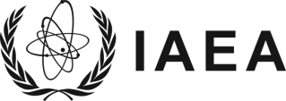
Atoms for Peace and Development
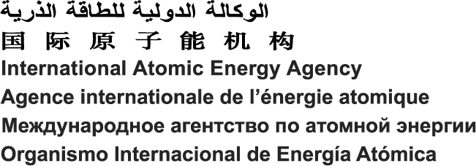
Vienna International Centre, PO Box 100, 1400 Vienna, Austria
Phone: (+43 1) 2600 • Fax: (+43 1) 26007
Email: Official.Mail@iaea.org • Internet: https://www.iaea.org
Reference: EVTXXXXXX
Scientific / Administrative Secretary: NAME SURNAME

CONFIDENTIALITY UNDERTAKING FOR NON-STAFF MEMBERS
(hired through a letter of invitation)
- I hereby undertake, as part of the terms and conditions of my contract with the International Atomic Energy Agency (IAEA) PASĀKUMA NOSAUKUMA (hereinafter referred to as "event"), not to disclose at any time during or after my participation in the event any confidential information which may come to my knowledge in connection with my participation in the event, including any commercial, technological or industrial secrets to which I have had access in the course of my contract, to any person, Government or organization not authorized to receive such information.
- I further undertake that, for the duration of my participation in the event, I shall:
    - follow the IAEA’s procedures for the safekeeping, handling and release of any such information;
    - restrict any use I make of such information, both within and outside the IAEA, to the proper execution of my official duties;
    - refrain from any unauthorized use of such information to my private advantage or to that of any third party.
- I undertake that, at all times following the termination of my participation in the event, I shall not use, disclose or disseminate any of the information referred to in paragraph 1 above, except as authorized by the Director General. I also undertake to take no action that may lead to such information being disclosed or exploited to the detriment of the IAEA, a Member State of the IAEA, a State Party to a Safeguards Agreement or a natural or legal person of such Member State or State Party.

______________________________
Date and Place

______________________________
Signature

______________________________
Name in block letters

